Maryland Overdose Response Program (ORP)
Online training now available

The Maryland Department of Health’s (MDH) Behavioral Health Administration partnered with the National Development and Research Institutes, Inc. to make available an existing online training and certificate module for Maryland ORP.
Individuals using a Maryland zip-code to register for the online training will receive an ORP certificate upon completion of the training. The certificate and prescription are not needed to get naloxone from a pharmacy.
Online Training Instructions:
- The link takes you directly to the sign up page.
http://www.getnaloxonenow.org/signup.aspx
- Set up an account. The site will take you to the training after setting up an account.
- The training takes about 20 minutes; a short quiz will follow. You can pause and return to the training.
- The site will prompt you to “Get Certificate” upon completion of training, which allows you to download an ORP certificate.
- If you prefer to attend a naloxone class, call 410-778-5980 or 5035
- Call 410-778-6404 for treatment resources or
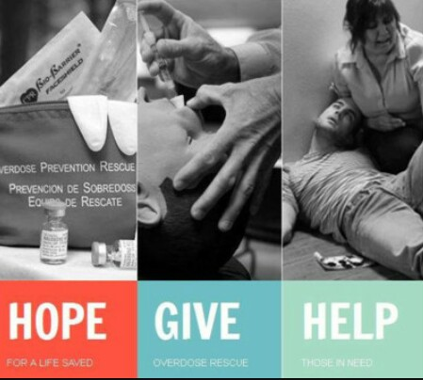
http://kenthd.org/

Getting Naloxone from a Pharmacy:
- Call ahead. Most pharmacies carry naloxone, but you may want to verify they have it in stock.
- Ask to speak with the pharmacist. Naloxone is a prescription drug, so it won’t be available with “over the counter” medications like aspirin.
- Mention the Statewide Standing Order, issued by Dr. Howard Haft, Maryland Department of Health. The Statewide Standing Order allows pharmacists to dispense naloxone to anyone without a paper or electronic prescription.
- Talk to the pharmacist about how to recognize an opioid overdose and administer naloxone.

