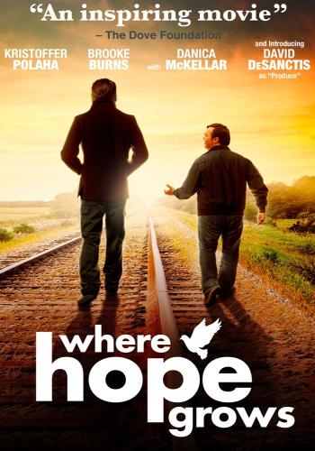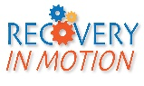

*Please join us for a family friendly cookout & movie under the stars. This is a* ***FREE*** *community event!!!!*

Lights, Camera, Action!

**Supporting Our Community and You!**

June 10, 2016 @ 6:00pm

Recovery In Motion

300 Scheeler Road * Chestertown, 21620

410-778-5894

You’re Invited To

Recovery In Motion’s 3rd Annual Backyard Bash

“A Night Under the Stars”